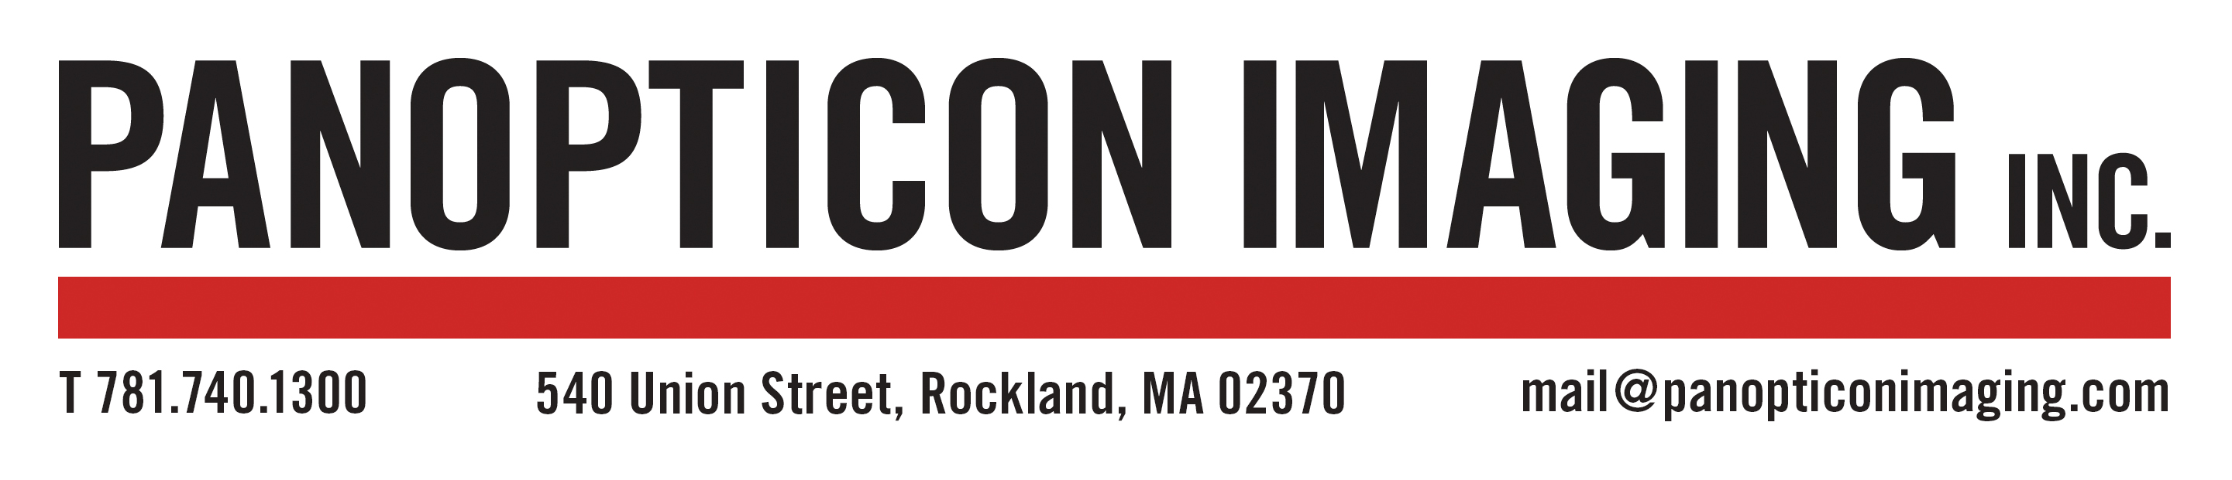

FILM PROCESSING AND PRICING

Developing beautiful negatives is our goal. We offer the finest custom machine processed and hand line film processing from 35mm to 8x10 sheet film. Specialty film processing is available upon request. Whole roll scans are made using our Fuji Frontier SP3000. They include an 8x10 contact sheet and are delivered as TIFF files in sRGB colorspace. These scans do not include any spotting or adjustments.

Scan sizes are as follows at 300dpi:
35mm & 6x9: 8x12in (about 2435px x 3635px)
6x4.5: 9x12in (about 2735px x 3635px)
6x6: 10x10in (about 3035px x 3035px)
6x7: 8.5x10in (about 2515px x 3035px)

Prints are 4x6 sized using our value printing service and will match the format of the negatives as follows:
35mm: 4x6in
6x4.5: 6x4.5in 6x6: 6x6in
6x7: 6x7in 6x9: 6x9

BLACK AND WHITE FILM
ROLL FILM
Service | 35mm (24exp.) & 120 | 35mm (36 exp.)
Develop Only | $15/ roll | $15/ roll
Develop & Contact* | $20/ roll | $20/ roll
Develop & Scan | $25/ roll | $25/ roll
Develop, Scan & Print** | $30/ roll | $35/ roll
Contact Only | $15/ roll | $15/ roll
Hand Line Processing | Additional $12/ roll
*B&W only **Prints are made using our value printing service.

COLOR POSITIVE FILM (E-6)
ROLL FILM
Service | 35mm (24exp.) & 120 | 35mm (36exp.)
Develop Only | $20/ roll | $20/ roll
Develop & Scan | $30/ roll | $30/ roll
Develop, Scan & Print | $35/ roll | $40/ roll

COLOR FILM (C-41)
ROLL FILM
Service | 35mm (24 exp.) & 120 | 35mm (36 exp.)
Develop Only | $15/ roll | $15/ roll
Develop & Scan | $25/ roll | $25/ roll
Develop, Scan & Print** | $30/ roll | $35/ roll
** Prints are made using our value print service.

SHEET FILM (B&W, C-41)
Film Type | Price
4x5 | $5/ sheet
8x10 | $12/ sheet
Add $2/ sheet for film in holders

